**CHAPTER 1**

**INTRODUCTION**

The primary objective of the proposed Leave Management System is to ensure the administration of standard leave policies, centralize the collection and maintenance of leave records, and automate as much of the process as possible. This system allows creating, monitoring, and routing of the leave applications from the applicants to the acting supervisors in the department and to the administrator of an organization. The Leave Management System enables employees with capabilities to submit leave requests online, check their leave-time balances and view the status of the leave requests via the World Wide Web (Web), relieving the organization from time-consuming inquiries. The automated leave management ensures that employees accrue the right amount of "leave" that they are entitled to receive, and provides a quick and efficient validation method that saves precious time and eliminates a cumbersome paper process. Also, enabling the supervisor to approve online requests saves management time. The Leave Management System calculates and maintains balances of each employee’s vacation, sick and other benefit time. It gives the organization the ability to review, edit, and approve employee time and leave from any location by using a standard Web browser. Thus, the Leave Management System simplifies the leave process, makes it more maintainable, gives better, clearer and more frequent information to end users, standardizes the processing of different types of leaves, and lowers the amount of data entry and verification activities.

This program runs on a local area network (LAN) and has the following features:

* submit and cancel leave requests,
* view leave transaction details, including the leave balances,
* approve, refuse,
* add new employees to the database and edit their information,
* update the leave database system,

The system has the many features that benefit the staffs:

* **Fast & Efficient**

The improved leave system has further streamlined the leave application/approval workflows such that it is much more convenient for staff make leave application and managers to approve.

* **Easy-to-Use**

The new LMS is specifically designed to be intuitive so that the system is very easy to learn and use by the administrators, approving offices and applicants.

* **Real-Time Information**

The new LMS operates on Real-Time whereby information is updated instantly whenever a leave transaction is completed. As such, all staff can check instantly who’s on leave, applying for leave or other status, etc.

* **Supports All Leave Types**

The new LMS is designed to support all existing leave types in the organization. All history leave records are tabulated automatically and archived securely in the system.

* **Integrates with HR, Time and Payroll System**

The new LMS is seamlessly integrated to the BMS to become 1 single system.

* **Single Sign-On**

There is no need to log into the new LMS again once user has already logon onto the Intranet. (Depending on company Intranet Policy)

**CHAPTER 3**

**PROBLEM DESCRIPTION**

In record based technique employee have to face many problem like maintaining the register, time will be wasted while managing the record of each employee manually. In thumb impression technique, if the employee is having the scar in his/her thumb then the thumb impression technique wouldn't work. It has many drawbacks likeit is time consuming process; there is a possibility for loss of records, tedious paper work;manual calculation may be wrong.

In proposed system chances of losing data is not possible because data is maintained in the form of database. Every leave and notices information is updated in to database using a user friendly GUI. This will reduce work of the organization. This application is an online application which makes more flexible to access information.

**CHAPTER 4**

**METHODOLOGY**

**4.1 DOTNET**

.NET is a general-purpose software enhancement platform, similar to Java. At its base is a virtual machine that turns intermediate language (IL) into machine code. High-level language compilers for C#, VB.NET, and C++ are provided to turn source code into IL. C# is a new programming language, very similar to Java. An extensive class library is included, featuring all the functionality one might expect from a contemporary development platform - windows GUI development (Windows Forms), database access (ADO.NET), web development (ASP.NET), web services, XML etc. It has five primary principles:

* Easier and Quick Programming.
* Reduced amount of code.
* Supports Software Lifecycle.
* It executes with high performance.
* Larger class library.

**4.2 DOT NET FRAMEWORK**

.NET is a framework that covers all the layers of software development above the Operating System. It provides the richest level of integration among presentation technologies, component technologies, and data technologies ever seen on Microsoft, or perhaps any, platform. Secondly, the entire architecture has been created to make it easy to develop Internet applications, as it is to develop for the desktop.

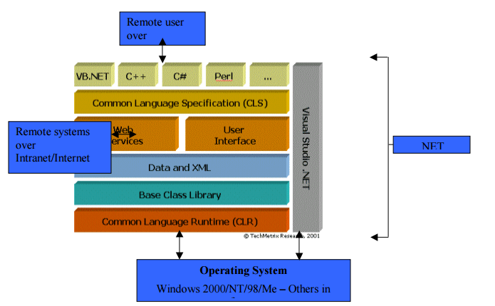

**Figure 4.1-Dot Net Framework Stack**

**4.2.1 COMMON RUNTIME LANGUAGE**

The Common Language Runtime (CLR) at the base is the CLR. It is considered as the heart of the .NET framework. .NET applications are compiled to a common language known as Microsoft Intermediate Language or “IL”. The CLR, then, handles the compiling the IL to machine language, at which point the program is executed. The CLR environment is also referred to as a managed environment, in which common services, such as garbage collection and security, are automatically provided.

**4.2.2 BASE CLASS LIBRARY**

The next layer up in the framework is called the .NET Class Framework also referred as .NET base class library. The .NET Class Framework consists of several thousand type definitions, where each type exposes some functionality. All in all, the CLR and the .NET Class Framework allow developers to build the following kinds of applications:

* Web Services. Components that can be accessed over the Internet very easily.
* Web Forms. HTML based applications (Web Sites).
* Windows Forms. Rich Windows GUI applications. Windows form applications can take advantage of controls; mouse and keyboard events and can talk directly to the underlying OS.
* Windows Console Applications. Compilers, utilities and tools are typically implemented as console applications.
* Windows Services. It is possible to build service applications controllable via the Windows Service Control Manager (SCM) using the .NET Framework.
* Component Library. .NET Framework allows you to build stand-alone components (types) that may be easily incorporated into any of the above mentioned application types.

**4.2.3 DATA AND XML**

ADO.NET is the next generation of Microsoft ActiveX Data Object (ADO) technology. ADO.NET is heavily dependent on XML for representation of data. It also provides an improved support for the disconnected programming model. ADO.NET’s Data Set object is the core component of the disconnected architecture of ADO.NET. The data Set can also be populated with data from an XML source, whether it is a file or an XML stream.

**4.2.4 LANGUAGE**

The CLR allows objects created in one language be treated as equal citizens by code written in a completely different language. To make this possible, Microsoft has defined a Common Language Specification (CLS) that details for compiler vendors the minimum set of features that their compilers must support if they are to target the runtime. Any language that conforms to the CLS can run on the CLR. In the .NET framework, Microsoft provides Visual Basic, Visual C++, Visual C#, and JScript support.

**4.3 MICROSOFT INTERMEDIATE LANGUAGE**

When compiling to managed code, the compiler translates your source code into Microsoft intermediate language (MSIL), which is a CPU-independent set of instructions that can be efficiently converted to native code. MSIL includes instructions for loading, storing, initializing, and calling methods on objects, as well as instructions for arithmetic and logical operations, control flow, direct memory access, exception handling, and other operations. Before code can be executed, MSIL must be converted to CPU-specific code by a just in time (JIT) compiler. Because the runtime supplies one or more JIT compilers, for each computer architecture it supports, the same set of MSIL can be JIT-compiled and executed on any supported architecture. When a compiler produces MSIL, it also produces metadata. The MSIL and metadata are contained in a portable executable (PE file) that is based on and extends the published Microsoft PE and Common Object File Format (COFF) used historically for executable content. This file format, which accommodates MSIL or native code as well as metadata, enables the operating system to recognize common language runtime images. The presence of metadata in the file along with the MSIL enables your code to describe itself, which means that there is no need for type libraries or Interface Definition Language (IDL). The runtime locates and extracts the metadata from the file as needed during execution.

**4.4 ASP.NET**

ASP.Net is a web development platform provided by Microsoft. It is used for creating web-based applications. ASP.Net was first released in the year 2002.

The first version of ASP.Net deployed was 1.0. The most recent version of ASP.Net is version 4.6. ASP.Net is designed to work with the HTTP protocol. This is the standard protocol used across all web applications.

ASP.Net applications can also be written in a variety of .Net languages. These include C#, VB.Net and J#.

**4.5 ASP.NET LIFE CYCLE**

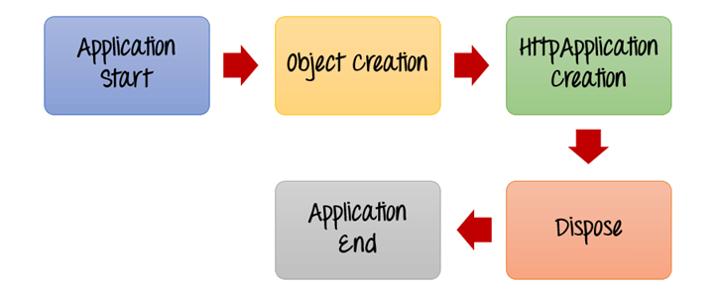

**Figure 4.2-ASP.NET Life Cycle**

**4.5.1 APPLICATION START**

The life cycle of an ASP.NET application starts when a request is made by a user. This request is to the Web server for the ASP.Net Application. This happens when the first user normally goes to the home page for the application for the first time. During this time, there is a method called Application start which is executed by the web server. Usually in this method, all global variables are set to their default values.

**4.5.2 OBJECT CREATION**

The next stage is the creation of the HttpContext, HttpRequest & HttpResponse by the web server. The HttpContext is just the container for the HttpRequest and HttpResponse objects. The HttpRequest object contains information about the current request, including cookies and browser information. The HttpResponse object contains the response that is sent to the client.

**4.5.3 HTTP APPLICATION CREATION**

This object is created by the web server. It is this object that is used to process each subsequent request sent to the application. For example, let's assume we have 2 web applications. One is a shopping cart application, and the other is a news website. For each application, we would have 2 HttpApplicationobjects created. Any further requests to each website would be processed by each HttpApplication respectively.

**4.5.4 DISPOSE**

This event is called before the application instance is destroyed. During this time, one can use this method to manually release any unmanaged resources.

### 4.6 ASP.Net Page Life cycle

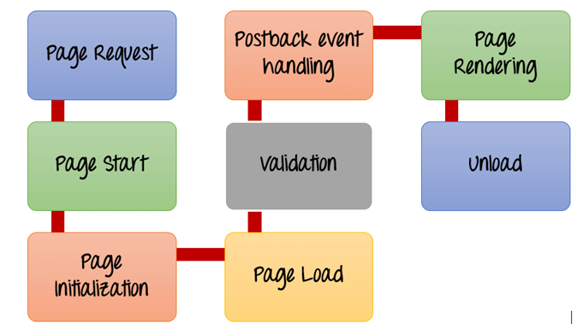

**Figure 4.3-ASP.NET Page Life Cycle**

1. **Page Request**

This is when the page is first requested from the server. When the page is requested, the server checks if it is requested for the first time. If so, then it needs to compile the page, parse the response and send it across to the user. If it is not the first time the page is requested, the cache is checked to see if the page output exists. If so, that response is sent to the user.

1. **Page Start**

During this time, 2 objects, known as the Request and Response object are created. The Request object is used to hold all the information which was sent when the page was requested. The Response object is used to hold the information which is sent back to the user.

1. **Page Initialization**

During this time, all the controls on a web page is initialized. So if you have any label, textbox or any other controls on the web form, they are all initialized.

1. **Page Load**

This is when the page is actually loaded with all the default values. So if a textbox is supposed to have a default value, that value is loaded during the page load time.

1. **Validation**

Sometimes there can be some validation set on the form. For example, there can be a validation which says that a list box should have a certain set of values. If the condition is false, then there should be an error in loading the page.

1. **Post back event handling**

This event is triggered if the same page is being loaded again. This happens in response to an earlier event. Sometimes there can be a situation that a user clicks on a submit button on the page. In this case, the same page is displayed again. In such a case, the Post back event handle is called.

1. **Page Rendering**

This happens just before all the response information is sent to the user. All the information on the form is saved, and the result is sent to the user as a complete web page.

1. **Unload**

Once the page output is sent to the user, there is no need to keep the ASP.net web form objects in memory. So the unloading process involves removing all unwanted objects from memory.

**4.7 ASP.NET MVC FRAMEWORK**

The Model-view-controller (MVC) is an architectural pattern framework developed by Microsoft which is an alternative to asp.net web forms for creating web application. The Asp.net MVC framework is a lightweight and testable framework with existing asp.net features such as master pages, authentication, etc. and it will split application into three components Model, view and controller.

**4.7.1 MODEL**

* A MVC Model is typically a class (of C# or VB.NET).
* Both the controller and view can access the Model.
* A Model can be used to pass data from a Controller to the View.
* The main purpose of a View is to display the data in a page using the Model.

**4.7.2 VIEW**

* A View is nothing but a page, you can say a web page, and it does not have code-behind
* All page specific HTML generation and formatting can be done inside the View
* A request to the View can be made only from a Controller's action method

**4.7.3 CONTROLLER**

* A Controller is typically a class (of C# or VB.Net) and inherits “system.mvc.controller”.
* Within this class, methods can be implemented and are called action methods. These are responsible for responding to the browser and/or calling the Views.
* The Controller class can access and use the Model class to pass data to the Views.

**4.8 WORKING OF MVC**

 The browser sends a request to ASP.Net MVC and it returns a response back to the browser (the request is a HTTP request and the response is a HTTP response).

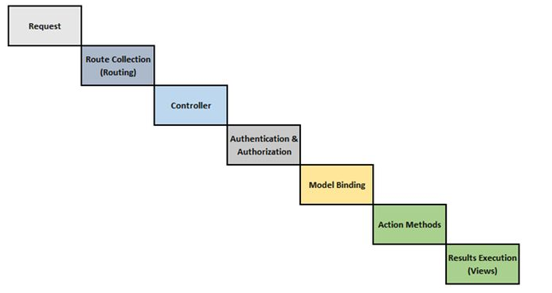

**Figure 4.4-Working of MVC**

The first request comes to the Route Tables then passes to a specific controller before interaction with the Model Binding. It goes through Authentication and Authorization and afterwards fires a specific Action Method and executes the results to the View.

### 4.9 ASP.NET MVC FEATURES

ASP.NET MVC provides the following features

* Ideal for developing complex but lightweight applications.
* Provides an extensible and pluggable framework, which can be easily replaced and customized. For example, if you do not wish to use the in-built Razor or ASPX View Engine, then you can use any other third-party view engines or even customize the existing ones.
* Utilizes the component-based design of the application by logically dividing it into Model, View, and Controller components. This enables the developers to manage the complexity of large-scale projects and work on individual components.
* MVC structure enhances the test-driven development and testability of the application, since all the components can be designed interface-based and tested using mock objects. Hence, ASP.NET MVC Framework is ideal for projects with large team of web developers.
* Supports all the existing vast ASP.NET functionalities, such as Authorization and Authentication, Master Pages, Data Binding, User Controls, Memberships, ASP.NET Routing, etc.
* Does not use the concept of View State (which is present in ASP.NET). This helps in building applications, which are lightweight and gives full control to the developers.

**4.10 MVC FLOW STEPS**

* The client browser sends request to the MVC Application.
* Global.ascx receives this request and performs routing based on the URL of the incoming request using the RouteTable, RouteData, UrlRoutingModule and MvcRouteHandler objects.
* This routing operation calls the appropriate controller and executes it using the IControllerFactory object and MvcHandler object's Execute method.
* The Controller processes the data using Model and invokes the appropriate method using ControllerActionInvoker object
* The processed Model is then passed to the View, which in turn renders the final output.

**4.11 MICROSOFT SQL SERVER**

It is a software , developed by Microsoft, which is implemented from the specification of RDBMS. It is also an ORDBMS. It is platform dependent. It is both GUI and command based software. It supports SQL (SEQUEL) language which is an IBM product, non-procedural, common database and case insensitive language. Usage of SQL Server

* To create databases.
* To maintain databases.
* To analyze the data through SQL Server Analysis Services (SSAS).
* To generate reports through SQL Server Reporting Services (SSRS).
* To carry out ETL operations through SQL Server Integration Services (SSIS).

## 4.11.1 SQL SERVER COMPONENTS

SQL Server works in client-server architecture, hence it supports two types of components − (a) Workstation and (b) Server.

* **Workstation components** are installed in every device/SQL Server operator’s machine. These are just interfaces to interact with Server components. Example: SSMS, SSCM, Profiler, BIDS, SQLEM etc.
* **Server components** are installed in centralized server. These are services. Example: SQL Server, SQL Server Agent, SSIS, SSAS, SSRS, SQL browser, SQL Server full text search etc.

**4.12 SQL ARCHITECTURE**

The architecture of SQL Server is classified into the following parts for easy understanding −

* General architecture
* Memory architecture
* Data file architecture
* Log file architecture

## 4.12.1 GENERAL ARCHITECTURE

**Client**−Where the request initiated.

**Query**−SQL query which is high level language.

**Logical Units**−Keywords, expressions and operators, etc.

**N/W Packets**−Network related code.

**Protocols** − In SQL Server we have 4 protocols.

* Shared memory (for local connections and troubleshooting purpose).
* Named pipes (for connections which are in LAN connectivity).
* TCP/IP (for connections which are in WAN connectivity).
* VIA-Virtual Interface Adapter (requires special hardware to set up by vendor and also deprecated from SQL 2012 version).

**Server** − Where SQL Services got installed and databases reside.

**Relational Engine** − This is where real execution will be done. It contains Query parser, Query optimizer and Query executor.

**Query Parser (Command Parser) and Compiler (Translator)** − This will check syntax of the query and it will convert the query to machine language.

**Query Optimizer** − It will prepare the execution plan as output by taking query, statistics and Algebrizer tree as input.

**Execution Plan** − It is like a roadmap, which contains the order of all the steps to be performed as part of the query execution.

**Query Executor** − This is where the query will be executed step by step with the help of execution plan and also the storage engine will be contacted.

**Storage Engine** − It is responsible for storage and retrieval of data on the storage system (disk, SAN, etc.,), data manipulation, locking and managing transactions.

**SQL OS** − This lies between the host machine (Windows OS) and SQL Server. All the activities performed on database engine are taken care of by SQL OS. SQL OS provides various operating system services, such as memory management deals with buffer pool, log buffer and deadlock detection using the blocking and locking structure.

**Checkpoint Process** − Checkpoint is an internal process that writes all dirty pages (modified pages) from Buffer Cache to Physical disk. Apart from this, it also writes the log records from log buffer to physical file. Writing of Dirty pages from buffer cache to data file is also known as Hardening of dirty pages.

It is a dedicated process and runs automatically by SQL Server at specific intervals. SQL Server runs checkpoint process for each database individually. Checkpoint helps to reduce the recovery time for SQL Server in the event of unexpected shutdown or system crash\Failure.

## 4.12.2 CHECKPOINTS IN SQL SERVER

* **Automatic** − This is the most common checkpoint which runs as a process in the background to make sure SQL Server Database can be recovered in the time limit defined by the Recovery Interval − Server Configuration Option.
* **Indirect** − This is new in SQL Server 2012. This also runs in the background but to meet a user-specified target recovery time for the specific database where the option has been configured. Once the Target_Recovery_Time for a given database has been selected, this will override the Recovery Interval specified for the server and avoid automatic checkpoint on such DB.
* **Manual** − This one runs just like any other T-SQL statement, once you issue checkpoint command it will run to its completion. Manual checkpoint runs for your current database only. You can also specify the Checkpoint_Duration which is optional - this duration specifies the time in which you want your checkpoint to complete.
* **Internal** − As a user you can’t control internal checkpoint. Issued on specific operations such as
  + Shutdown initiates a checkpoint operation on all databases except when shutdown is not clean (shutdown with nowait).
  + If the recovery model gets changed from Full\Bulk-logged to Simple.
  + While taking backup of the database.
  + If your DB is in simple recovery model, checkpoint process executes automatically either when the log becomes 70% full, or based on Server option-Recovery Interval.
  + Alter database command to add or remove a data\log file also initiates a checkpoint.
  + Checkpoint also takes place when the recovery model of the DB is bulk-logged and a minimally logged operation is performed.
* **Lazy Writer Process** − Lazy writer will push dirty pages to disk for an entirely different reason, because it needs to free up memory in the buffer pool. This happens when SQL server comes under memory pressure. As far as I am aware, this is controlled by an internal process and there is no setting for it.

**4.12.3 MEMORY ARCHITECTURE**

* One of the primary design goals of all database software is to minimize disk I/O because disk reads and writes are among the most resource-intensive operations.
* Memory in windows can be called with Virtual Address Space, shared by Kernel mode (OS mode) and User mode (Application like SQL Server).
* SQL Server "User address space" is broken into two regions: MemToLeave and Buffer Pool.
* Size of MemToLeave (MTL) and Buffer Pool (BPool) is determined by SQL Server during startup.
* **Buffer management** is a key component in achieving I/O highly efficiency. The buffer management component consists of two mechanisms: the buffer manager to access and update database pages, and the buffer pool to reduce database file I/O.
* The buffer pool is further divided into multiple sections. The most important ones being the buffer cache (also referred to as data cache) and procedure cache. **Buffer cache** holds the data pages in memory so that frequently accessed data can be retrieved from cache. The alternative would be reading data pages from the disk. Reading data pages from cache optimizes performance by minimizing the number of required I/O operations which are inherently slower than retrieving data from the memory.
* **Procedure cache** keeps the stored procedure and query execution plans to minimize the number of times that query plans have to be generated. You can find out information about the size and activity within the procedure cache using DBCC PROCCACHE statement.

Other portions of buffer pool include −

* **System level data structures** − Holds SQL Server instance level data about databases and locks.
* **Log cache** − Reserved for reading and writing transaction log pages.
* **Connection context** −Each connection to the instance has a small area of memory to record the current state of the connection. This information includes stored procedure and user-defined function parameters, cursor positions and more.
* **Stack space** − Windows allocates stack space for each thread started by SQL Server.

**4.12.4 DATA FILE ARCHITECTURE**

### File Groups

Database files can be grouped together in file groups for allocation and administration purposes. No file can be a member of more than one file group. Log files are never part of a file group. Log space is managed separately from data space. There are two types of file groups in SQL Server, Primary and User-defined. Primary file group contains the primary data file and any other files not specifically assigned to another file group. All pages for the system tables are allocated in the primary file group. User-defined file groups are any file groups specified using the file group keyword in create database or alter database statement.

One file group in each database operates as the default file group. When SQL Server allocates a page to a table or index for which no file group was specified when they were created, the pages are allocated from default file group. To switch the default file group from one file group to another file group, it should have db owner fixed db role.

### Files

Databases have three types of files - Primary data file, Secondary data file, and Log file. Primary data file is the starting point of the database and points to the other files in the database. Every database has one primary data file. We can give any extension for the primary data file but the recommended extension is **.mdf**. Secondary data file is a file other than the primary data file in that database. Some databases may have multiple secondary data files. Some databases may not have a single secondary data file. Recommended extension for secondary data file is **.ndf**.

Log files hold all of the log information used to recover the database. Database must have at least one log file. We can have multiple log files for one database. The recommended extension for log file is **.ldf**.

### Extents

Extents are basic unit in which space is allocated to tables and indexes. An extent is 8 contiguous pages or 64KB. SQL Server has two types of extents - Uniform and Mixed. Uniform extents are made up of only single object. Mixed extents are shared by up to eight objects.

### Pages

It is the fundamental unit of data storage in MS SQL Server. The size of the page is 8KB. The start of each page is 96 byte header used to store system information such as type of page, amount of free space on the page and object id of the object owning the page.

**4.12.5 LOG FILE ARCHITECTURE**

The SQL Server transaction log operates logically as if the transaction log is a string of log records. Each log record is identified by Log Sequence Number (LSN). Each log record contains the ID of the transaction that it belongs to.

Log records for data modifications record either the logical operation performed or they record the before and after images of the modified data. The before image is a copy of the data before the operation is performed; the after image is a copy of the data after the operation has been performed.

The steps to recover an operation depend on the type of log record −

* Logical operation logged.
  + To roll the logical operation forward, the operation is performed again.
  + To roll the logical operation back, the reverse logical operation is performed.
* Before and after image logged.
  + To roll the operation forward, the after image is applied.
  + To roll the operation back, the before image is applied.

Different types of operations are recorded in the transaction log. These operations include −

* The start and end of each transaction.
* Every data modification (insert, update, or delete). This includes changes by system stored procedures or data definition language (DDL) statements to any table, including system tables.
* Every extent and page allocation or de allocation.
* Creating or dropping a table or index.

Rollback operations are also logged. Each transaction reserves space on the transaction log to make sure that enough log space exists to support a rollback that is caused by either an explicit rollback statement or if an error is encountered. This reserved space is freed when the transaction is completed.

The section of the log file from the first log record that must be present for a successful database-wide rollback to the last-written log record is called the active part of the log, or the active log. This is the section of the log required to a full recovery of the database. No part of the active log can ever be truncated. LSN of this first log record is known as the minimum recovery LSN (Min LSN).

The SQL Server Database Engine divides each physical log file internally into a number of virtual log files. Virtual log files have no fixed size, and there is no fixed number of virtual log files for a physical log file. The Database Engine chooses the size of the virtual log files dynamically while it is creating or extending log files. The Database Engine tries to maintain a small number of virtual files. The size or number of virtual log files cannot be configured or set by administrators. The only time virtual log files affect system performance is if the physical log files are defined by small size and growth increment values. The size value is the initial size for the log file and the growth increment value is the amount of space added to the file every time new space is required. If the log files grow to a large size because of many small increments, they will have many virtual log files. This can slow down database startup and also log backup and restore operations.

**CHAPTER 5**

**PRESENT WORK**

System design is the process of defining the elements of a system such as the architecture, modules and components, the different interfaces of those components and the data that goes through that system. It is meant to satisfy specific needs and requirements of a business or organization through the engineering of a coherent and well-running system. Systems design could see it as application of systems theory to product development. There is some overlap with the discipline of the system analysis, architecture and engineering. Conceptual design is not the end of design process. It serves as the basis for a brief design. System design implies a systematic and rigorous approach to the design as demanded by complexity of many system problems.

**5.1 UNIFIED MODELING LANGUAGE**

UML can be described as the successor of object oriented analysis and design. An object contains both data and methods that control the data. The data represents the state of the object. A class describes an object and they also form hierarchy to model real world system. The hierarchy is represented as inheritance and the classes can also be associated in different manners as per the requirement. The objects are the real world entities that exist around us and the basic concepts like abstraction, encapsulation, inheritance, polymorphism all can be represented using UML. So UML is powerful enough to represent all the concepts exists in object oriented analysis and design. UML diagrams are representation of object oriented concept.

**5.1.1 USE CASE DIAGRAM**

Use case diagrams are a set of use cases, actors and their relationships. They represent the use case view of a system. A use case represents a particular functionality of a system. So use case diagram is used to describe the relationships among the functionalities and their internal/external controllers. These controllers are known as actors.

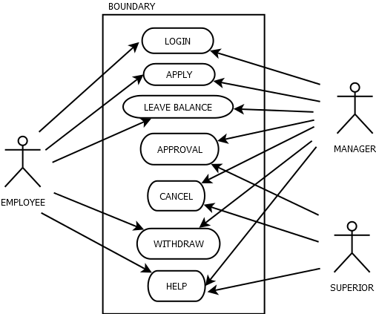

**Figure 5.1-Use Case Diagram**

**5.1.2** **ACTIVITY DIAGRAM**

Activity diagram describes the flow of control in a system. So it consists of activities and links. The flow can be sequential, concurrent or branched. Activities are nothing but the functions of a system. Numbers of activity diagrams are prepared to capture the entire flow in a system. Activity diagrams are used to visualize the flow of controls in a system. This is prepared to have an idea of how the system will work when executed.

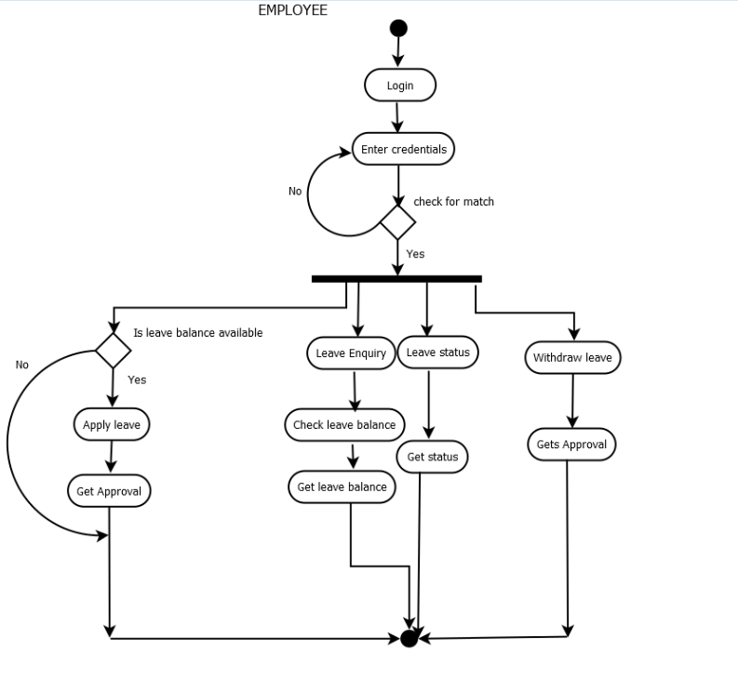

**Figure 5.2-Employee Activity Diagram**

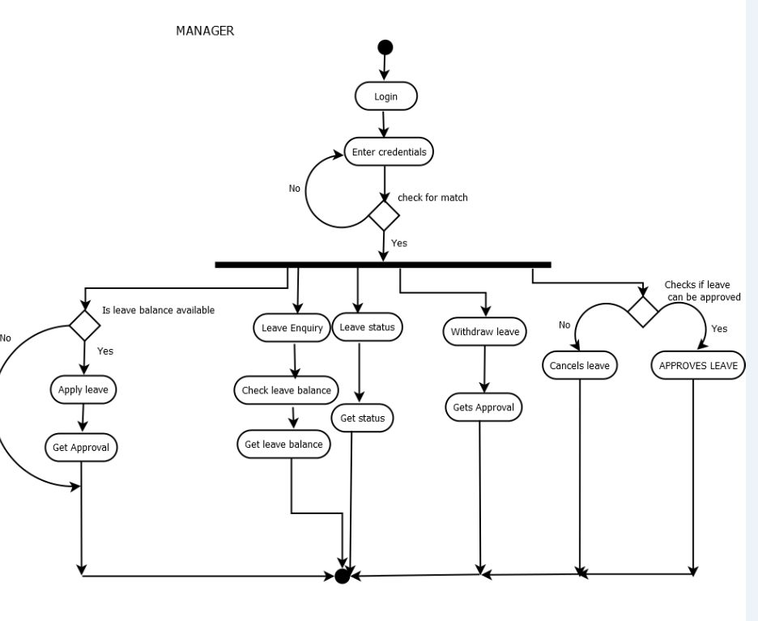

**Figure 5.3-Manager Activity Diagram**

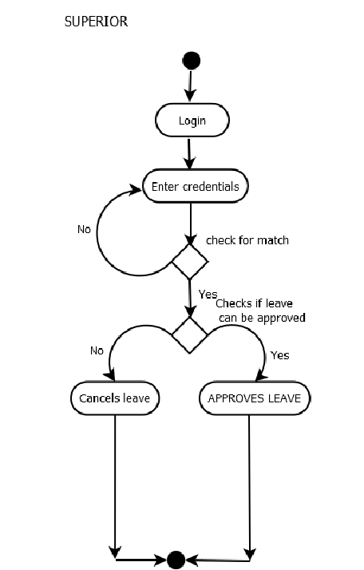

**Figure 5.4-Superior Activity Diagram**

**5.1.3 CLASS DIAGRAM**

Class diagrams are the most common diagrams used in UML. Class diagram consists of classes, interfaces, associations and collaboration. Class diagrams basically represent the object oriented view of a system which is static in nature. Active class is used in a class diagram to represent the concurrency of the system. Class diagram represents the object orientation of a system. So it is generally used for development purpose. This is the most widely used diagram at the time of system construction.

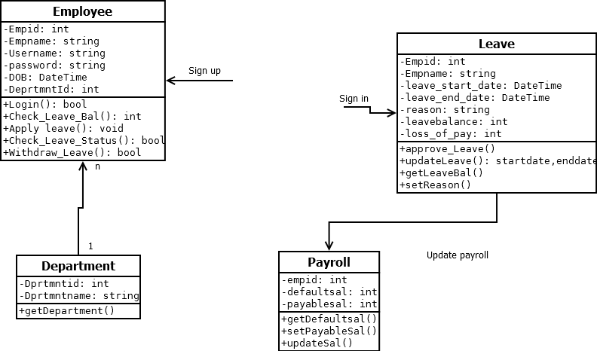

**Figure 5.5-Class Diagram**

**5.1.4 SEQUENCE DIAGRAM**

A sequence diagram is an interaction diagram. From the name it is clear that the diagram deals with some sequences, which are the sequence of messages flowing from one object to another. Interaction among the components of a system is very important from implementation and execution perspective. So Sequence diagram is used to visualize the sequence of calls in a system to perform a specific functionality.

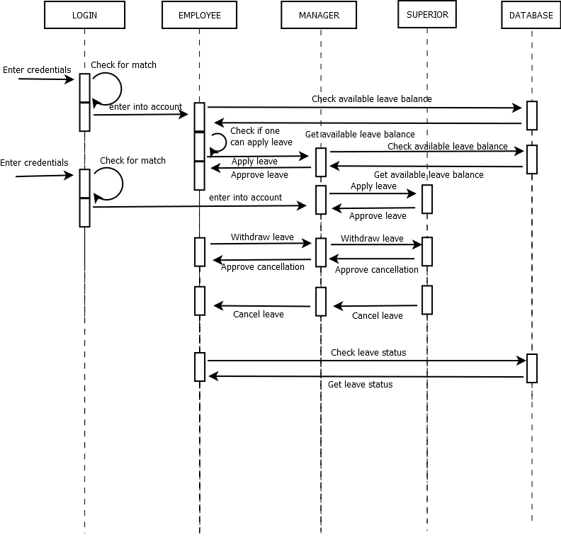

**Figure 5.6-Sequence Diagram**

**5.2 ENTITY RELATIONSHIP DIAGRAM**

Entity-relationship (ER) diagram, is a graphical representation of entities and their relationships to each other, typically used in computing in regard to the organization of data within databases or information systems.

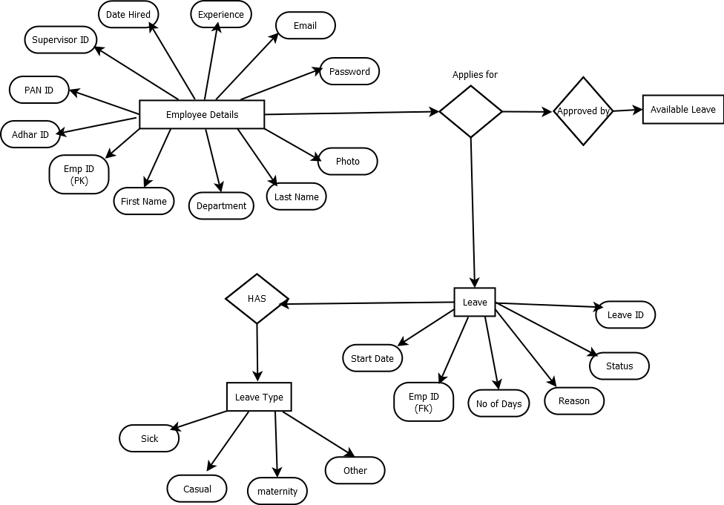

**Figure 5.7-Entity Relationship Diagram**

**Results**

